**Name: Saurabh Sanjay Karande**

**Enrollment No. : 1910510476**

**Sub: MAD**

**Assignment 1**

**---------------------------------------------------------------------------------------------**

**Q1.Define Android operating system.**

**Ans: a).Android is a complete set of software for mobile devices such as tablet computers,notebooks, smartphones, electronic book readers, set-top boxes etc.**

**b). Android is a software package and linux based operating system for mobile devices such as tablet computers and smartphones.**

**Q2.Explain following :1) Open handset alliance  2) Android Ecosystem.**

**Ans: 1).Open handset alliance: a).The Open Handset Alliance (OHA) is a**[**consortium**](https://en.wikipedia.org/wiki/Consortium)**of 84firms to develop**[**open standards**](https://en.wikipedia.org/wiki/Open_standard)**for**[**mobile devices**](https://en.wikipedia.org/wiki/Mobile_device)**. Member firms include**[**HTC**](https://en.wikipedia.org/wiki/HTC)**,**[**Sony**](https://en.wikipedia.org/wiki/Sony)**,**[**Dell**](https://en.wikipedia.org/wiki/Dell)**,**[**Intel**](https://en.wikipedia.org/wiki/Intel)**,**[**Motorola**](https://en.wikipedia.org/wiki/Motorola)**,**[**Qualcomm**](https://en.wikipedia.org/wiki/Qualcomm)**,**[**Texas Instruments**](https://en.wikipedia.org/wiki/Texas_Instruments)**,**[**Google**](https://en.wikipedia.org/wiki/Google)**,**[**Samsung Electronics**](https://en.wikipedia.org/wiki/Samsung_Electronics)**,**[**LG Electronics**](https://en.wikipedia.org/wiki/LG_Electronics)**,**[**T-Mobile**](https://en.wikipedia.org/wiki/T-Mobile)**,**[**Sprint Corporation**](https://en.wikipedia.org/wiki/Sprint_Corporation)**,and**[**Wind River Systems**](https://en.wikipedia.org/wiki/Wind_River_Systems)**.**

**b).** [**Android**](https://en.wikipedia.org/wiki/Android_(operating_system))**, the flagship software of the alliance (first developed by Google in 2007), is based on an open-source license and has competed against mobile platforms from**[**Apple**](https://en.wikipedia.org/wiki/Apple_Inc.)**([iOS](https://en.wikipedia.org/wiki/IOS)),**[**Microsoft**](https://en.wikipedia.org/wiki/Microsoft)**(**[**Windows Phone**](https://en.wikipedia.org/wiki/Windows_Phone)**),**[**Nokia**](https://en.wikipedia.org/wiki/Nokia)**(**[**Symbian**](https://en.wikipedia.org/wiki/Symbian)**),**[**HP**](https://en.wikipedia.org/wiki/Hewlett-Packard)**(formerly**[**Palm**](https://en.wikipedia.org/wiki/Palm,_Inc.)**),**[**Samsung Electronics**](https://en.wikipedia.org/wiki/Samsung_Electronics)**/**[**Intel**](https://en.wikipedia.org/wiki/Intel)**([Tizen](https://en.wikipedia.org/wiki/Tizen), [bada](https://en.wikipedia.org/wiki/Bada)), and**[**BlackBerry**](https://en.wikipedia.org/wiki/BlackBerry_Ltd)**(**[**BlackBerry OS**](https://en.wikipedia.org/wiki/BlackBerry_OS)**).**

**2). Android Ecosystem: a). Ecosystem in Market terminology refers to the inter-dependence between demand and supply.**

**b). Users buy devices and applications.**

**Q3.**  **List and explain feature of Android**.

**Ans: * Feature List of Android:**

**1.Beautiful UI**

**2.Connectivity**

**3.Storage**

**4.Media Support**

**5.Messaging**

**6.Multi-touch**

**7.Multi-tasking**

**8.Resizable widgets**

**9.Multi-Language**

**10.GCM**

**11.Wi-fi Direct**

**12.Android Beam.**

**\* explain feature of Android:**

**1.Beautiful UI:** **Android OS basic screen provides a beautiful and intuitive user interface.**

**2.Connectivity:** **GSM/EDGE, IDEN, CDMA, EV-DO, UMTS, Bluetooth, Wi-Fi, LTE, NFC and WiMAX. Storage SQLite, a lightweight relational database, is used for data storage purposes.**

**3.Storage:** **SQLite, a lightweight relational database, is used for data storage purposes.**

**4.Media Support:** **H.263, H.264, MPEG-4 SP, AMR, AMR-WB, AAC, HE-AAC, AAC 5.1, MP3, MIDI, Ogg Vorbis, WAV, JPEG, PNG, GIF, and BMP**

**5.Messanging: SMS and MMS Web browser Based on the open-source WebKit layout engine, coupled with Chrome's V8 JavaScript engine supporting HTML5 and CSS3.**

**6.Multi-touch: Android has native support for multi-touch which was initially made available in handsets such as the HTC Hero.**

**7.Multi-tasking:** **User can jump from one task to another and same time various application can run simultaneously.**

**8.Resizable widgets:** **Widgets are resizable, so users can expand them to show more content or shrink them to save space**

**9.Multi-Language:** **Support single direction and bi-directional text.**

**10.GCM: Google Cloud Messaging (GCM) is a service that let developers send short message data to their users on Android devices, without needing a proprietary sync solution.**

**11.Wi-fi direct: A technology that let apps discover and pair directly, over a highband width peer-to-peer connection.**

**12.Android Beam:** **A popular NFC-based technology that let users instantly share, just by touching two NFC-enabled phones together.**

**Q4.Which tools and software’s are required for developing an Android Application?**

**Ans:** **1**.**Java JDK5 or JDK6**

**2. Android SDK**

**3.Eclipse IDE for Java Developers (optional)**

**4.Android Development Tools (ADT).**

**Q5.Explain android Architecture with neat diagram.**

**Ans: Android architecture** is a software stack of components to support mobile device needs. **Android** software stack contains a Linux Kernel, collection of c/c++ libraries which are exposed through an application framework services, runtime, and application.

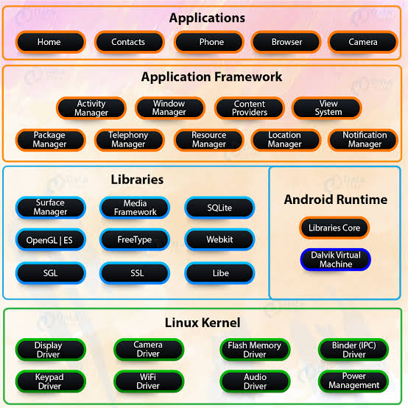

**Q6.List all versions of android operating system.**

**Ans:a) 1.5- Cupcake.**

**b) 1.6-Donut.**

**c) 2.1-Éclair.**

**d) .3-Gingerbread.**

**e) 3.1&3.3-HoneyComb.**

**f) 4.0-IceCream Sandwitch.**

**g) 4.1,4.2&4.3-Jelly Bean.**

**h) 4.4-Kitkat.**

**i) 5.0-Lollipop.**

**j) 6.0- Marshmallow.**

**k) 7.0-Nougat.**

**L) 8.0-Oreo.**

**m) 9.0-pie.**

**n) 10.0- Android 10.**